Experiment1.1

Student Name: Himanshu UID: 20BCS7944
Branch: CSE Section: 905/A
Semester: 6 Date of Performance: 16/02/2023
Subject Name: IOT Lab Subject Code: 20CSP-358

1) Aim:

Analyse the components of an IOT system.

2) Objective:

Familiarization with Arduino Uno and Raspberry Pi hardware.
3) Arduino Uno:

Arduino Uno is a microcontroller board based on the Atmel AVR microcontroller. One of the main advantages of the Arduino Uno is its simplicity and ease of use. The board comes with a USB interface that allows it to be easily connected to a computer, and it uses a simple programming language based on C/C++ that is easy to learn even for beginners.
In addition, the Arduino Uno has a wide range of shields and modules available, which can be easily added to the board to expand its capabilities and create more complex projects.

4) Key features of Arduino Uno:

- Microcontroller: The Arduino Uno is based on the Atmel AVR microcontroller, which has 32KB of flash memory, 2KB of SRAM, and 1KB of EEPROM.
- Digital I/O Pins: The board has 14 digital input/output pins that can be used for connecting sensors, actuators, and other devices.
- Analog Input Pins: The board has 6 analog input pins that can be used to read analog signals from sensors.
- PWM Output Pins: The board has 6 PWM (Pulse Width Modulation) output pins that can be used for controlling the speed of motors or the brightness of LEDs.
- USB interface: The board has a USB interface that allows it to be easily connected to a computer for programming and serial communication.
- Power Supply: The board can be powered using a USB cable or an external power supply (7-12V DC).
- Integrated Development Environment (IDE): The Arduino IDE is a software tool that provides a simple and user-friendly environment for writing and uploading code to the board.
- Shields: The board has a range of shields and modules available that can be easily added to the board to expand its capabilities and create more complex projects.

Overall, the Arduino Uno is a versatile and easy-to-use microcontroller board that is suitable for a wide range of electronics projects, from simple LED blinking projects to more complex robotics and automation projects.

5) Devices that can be connected to Arduino Uno:
There are many different sensors and actuators that can be connected to an Arduino Uno board. Here are some common examples of sensors and actuators that can be used with the Arduino Uno:

Sensors:
- Temperature sensor (e.g., LM35)
- Light sensor (e.g., photoresistor)
- Proximity sensor (e.g., ultrasonic sensor)
- Motion sensor (e.g., PIR sensor)
- Gas sensor (e.g., MQ-2 sensor)
- Sound sensor (e.g., microphone)

Actuators:
- LED (light-emitting diode)
- Motor (e.g., DC motor, servo motor, stepper motor)
- Buzzer
- Relay
- Solenoid
- LCD display

Arduino Image -

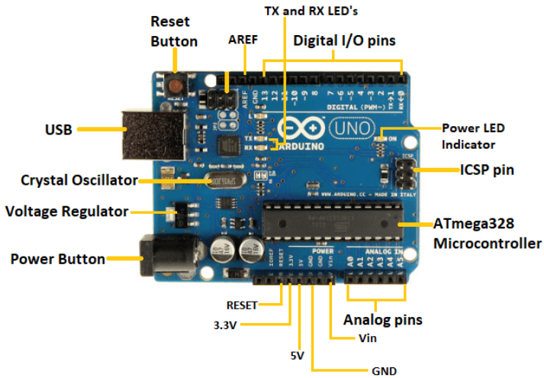
5) Raspberry Pi:
Raspberry Pi is a credit card-sized single-board computer that runs on Linux operating system. It is designed to be a general-purpose computer that can run a variety of software applications, from basic programming tools to web servers and media centers.
Raspberry Pi has a range of models available, each with varying specifications, but all models have at least one HDMI port, audio jack, USB ports, and an Ethernet port for connectivity. Raspberry Pi can be programmed using a range of languages, including Python, C++, and Java.

6) Key features of Raspberry Pi:

- Raspberry Pi is a low-cost, credit-card-sized computer that can be used for a variety of purposes. Here are some key features of Raspberry Pi:
- Low cost: One of the most significant features of the Raspberry Pi is its low cost. It is an affordable computer that can be used for a range of projects.
- Small size: Raspberry Pi is incredibly small, about the size of a credit card. This feature makes it highly portable and easy to work with.
- GPIO pins: The GPIO (General Purpose Input/Output) pins on Raspberry Pi allow you to connect it to various sensors, lights, and other devices, making it ideal for building electronic projects.
- Operating system: Raspberry Pi can run a variety of operating systems, including Linux, Windows 10 IoT Core, and others. This versatility makes it a popular choice for hobbyists, educators, and developers.
- Programming languages: Raspberry Pi supports several programming languages, including Python, C++, and Java, making it an excellent platform for learning programming.
- Multimedia capabilities: Raspberry Pi has multimedia capabilities that allow it to handle audio and video playback and capture. It can also be used for gaming and other multimedia applications.
- WiFi and Bluetooth: Raspberry Pi has built-in WiFi and Bluetooth capabilities, allowing it to connect to other devices and networks wirelessly.
- Camera interface: Raspberry Pi has a camera interface that allows you to connect a camera module to capture images and video.
Overall, the Raspberry Pi's low cost, small size, and versatility make it an excellent choice for a wide range of applications, including home automation, robotics, education, and more.

7) Interfacing Raspberry Pi with the computer:
There are several ways to interface a Raspberry Pi with a computer, depending on what we want to achieve.
- SSH: Secure Shell (SSH) is a protocol that allows access to the command line interface of a Raspberry Pi remotely. To use SSH, enable it on Raspberry Pi and then connect to it using a terminal on computer.
- VNC: Virtual Network Computing (VNC) allows access to the graphical user interface of a Raspberry Pi remotely. To use VNC, install and configure a VNC server on Raspberry Pi, and then use a VNC client on computer to connect to the server.
- Ethernet: We can connect Raspberry Pi and computer using an Ethernet cable to create a wired network. This allows us to transfer files between the two devices and share an internet connection.
- Wi-Fi: We can also connect Raspberry Pi and computer to the same Wi-Fi network to create a wireless network. This allows to transfer files between the two devices and share an internet connection.
- USB: We can use a USB cable to connect your Raspberry Pi and computer, and use the USB connection to transfer files between the two devices.

Once we have connected the Raspberry Pi and computer, we can use a variety of tools and software to interact with the Raspberry Pi, such as accessing the file system, running commands, and running applications.

8) Difference between Raspberry Pi and Arduino Uno:
- The main difference between Raspberry Pi and Arduino Uno is that Raspberry Pi is a more powerful and versatile computing platform, while Arduino Uno is a simpler microcontroller board designed specifically for electronics projects.
- Raspberry Pi is better suited for projects that require more computing power, networking capabilities, and support for a range of programming languages, while Arduino Uno is better suited for simpler electronics projects that require interfacing with external devices.

Raspberry Pi Image -

